**French Press Coffee**

Describing a Process

**Part 1 Vocab Preview** *Try to infer the meaning of the underlined words before you watch the video.*

1. Whenever I use my French press, my coffee is either too silty or too sludgy.
2. There are no bubbles when I wash my dishes because we have hard water in my neighborhood.
3. Do you think it is better to use finely ground coffee or coarsely ground coffee?
4. After you put the teabag in water, let it sit for five minutes.
5. Push the plunger down to the bottom of the French press and then pour the coffee into a cup.
6. There is always some sediment at the bottom of the cup when I finish drinking my coffee.

**Part 2 Comprehension** *Decide if each statement is true or false.*

1. **T / F** This is a good method to make a quick delicious cup of coffee using a French press.
2. **T / F** You should always use pre-ground coffee for the best results with a French press.
3. **T / F** Hard water is ideal for brewing coffee with a French press.
4. **T / F** The coffee should be ground to a coarse consistency for this method.
5. **T / F** You should stir the crust that forms on top of the coffee.
6. **T / F** It is okay to scoop off some of the crust and throw it in the sink.
7. **T / F** You should push the plunger to the bottom of the French press to filter the coffee.
8. **T / F** You should wait five to eight minutes before you pour it into a cup.

**Part 3 Grammar** *Giving directions often uses either the imperative (no subject) or modal verbs. In each black, decide if you should add “you” or leave it empty (imperative). Add capital letters where necessary.*

1. If _____ are in a hurry, this really isn't going to work for you.
2. _____ need to get some delicious coffee.
3. _____ are going to grind it fresh if _____ want the best possible experience.
4. _____ don't brew with hard water. _____ don't brew with unfiltered water.
5. After _____ grind your coffee, _____ put it in the French press.
6. _____ ignore what most people say. _____ don't grind super coarse. _____ grind something more like _____ would describe as medium.
7. _____ boil your water and then _____ pour the right amount of water on top.
8. _____ will be left with some bits on top. _____ want to scoop those off. _____ just throw them down the sink.
9. After seven or eight minutes, now _____ can drink it.
10. When _____ put the plunger in, _____ do not plunge all the way.
11. And then _____ gently pour the coffee through into the cup.

**Part 4 Discussion** *Discuss these questions with your group.*

1. Have you used a French press to make coffee? If so, did you follow this method? Did you do anything differently?
2. What are some other methods to brew coffee? Which ones have you used?
3. In your opinion, which method produces the best cup of coffee? Why? Can you describe the differences in taste?
4. Why do you think he recommends using soft water instead of hard water? Do you agree?
5. What was your best cup of coffee ever? Did you make it yourself, or buy it somewhere? Can you describe the flavor?
6. 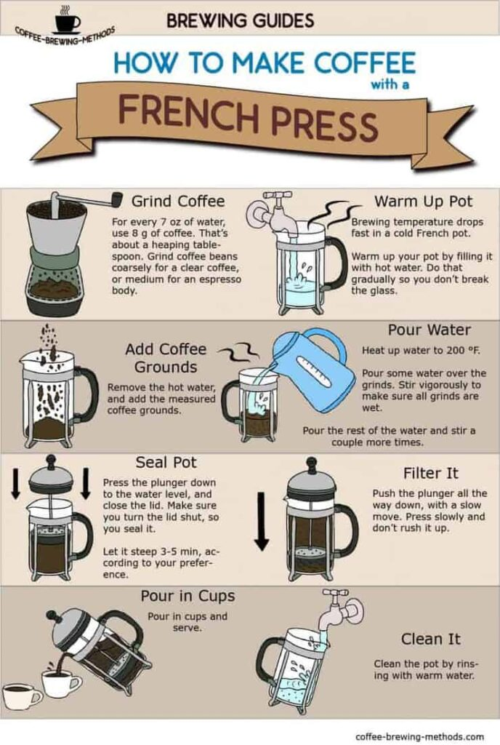Here are the instructions from a French press. How are they similar to the video? How are they different?

**Part 5 Sentence Building** *Write sentences about the video clip using the words given. You can change the word form or add words, but you cannot change the word order.*

E.g. this / how / make / smooth / delicious / sludge / free / cup / coffee / use / French / press

This is how to make a smooth, delicious, sludge-free cup of coffee using a French press.

1. first / you / need / use / fresh / roast / fresh / ground / coffee
2. you / should / also / use / soft / clean / water / as / hard / unfiltered / water / can / affect / taste
3. although / many / people / say / coarse / ground / coffee / best / James / recommend / use / medium / ground / coffee
4. after / you / grind / coffee / pour / boil / water / over / coffee / stir / after / four / minute / and / remove / any / foam / or / float / bit
5. stir / after / four / minute / and / then / remove / any / foam / or / float / bit
6. now / just / let / coffee / sit / seven / eight / minute / allow / sediment / settle
7. now / just / let / coffee / sit / seven / eight / minute / so / sediment / can / settle
8. long / you / leave / it / good / it / going / taste
9. next / insert / plunger / but / not / push / it / all / way / bottom
10. only / thing / left / do / pour / coffee / cup / and / enjoy

**Script g**

This is how to get incredible results with a French press. We're looking for a really delicious cup of coffee with none of the silty-sludgy stuff at the bottom.

If you're in a hurry, this really isn't going to work for you. This is a really great way to make coffee, but it's not very quick. You need a little bit of patience that will be rewarded.

You need to get some delicious coffee. Delicious means fresh, like freshly roasted, and you're going to grind it fresh if you want the best possible experience. This will work with pre-ground coffee, but it won't taste as good as it could, so grind fresh.

I would recommend starting between 60 and 70 grams per liter. How you like it is up to you.

Fresh, clean, soft water. Don't brew with hard water. Don't brew with unfiltered water. If it doesn't taste delicious on its own, it's not going to make great tasting coffee.

So, here's how this is going to work. When you grind your coffee, put it in the French press. Ignore what most people say. Don't grind super coarse. Grind something more like you describe as medium.

Boil your water. Don't worry too much about this as long as it's boiled, and then pour the right amount of water on top. I might brew 30 grams of coffee to 500 grams of water.

And then, we're going to let it sit for four minutes. Just hang out, wait, be patient.

We're going to grab a couple of tablespoons. With one of them, we're going to stir the crust that forms on top of the coffee. A lot of it will start to fall away, and then you'll be left with some bits on top, some foam, some floating bits. You want to scoop those off. Just throw them down the sink. It's fine.

Now, here's the bit that seems difficult. I want you to do nothing at all for at least five minutes.

Now this is a little frustrating because you feel like you've brewed the coffee, but even if you pour it into a cup, it's too hot to drink right now anyway. And the longer you leave it, the better it's going to taste.

As you sit, all of those floating bits start to fall down to the bottom of the press and settle in that bed of coffee. This is exactly what we want. We don't want those in the cup; we want those stuck down at the bottom of the cafetiere.

After five, maybe seven, eight minutes, now you can drink it.

When you put the plunger in, do not plunge all the way. All you're going to do there is stir up all the sediment all over again. So just til it's sitting on the surface of the coffee. We can use it as a strainer in case there's any big pieces that are still floating around, but we shouldn't really need it. And then gently pour the coffee through into the cup.

This will be the most delicious silt-sludge-free cup of coffee you will get from a French press.

Enjoy.

**Answers g**

**Part 2**

1. **T / F** This is a good method to make a quick delicious cup of coffee using a French press.
2. **T / F** You should always use pre-ground coffee for the best results with a French press.
3. **T / F** Hard water is ideal for brewing coffee in a French press.
4. **T / F** The coffee should be ground to a coarse consistency for this method.
5. **T / F** You should stir the crust that forms on top of the coffee.
6. **T / F** It is okay to scoop off some of the crust and throw it in the sink.
7. **T / F** You should push the plunger to the bottom of the French press to filter the coffee.
8. **T / F** You should wait five to eight minutes before you pour it into a cup.

**Part 3**

1. If **you** are in a hurry, this really isn't going to work for you.
2. **You** need to get some delicious coffee.
3. **You** are going to grind it fresh if **you** want the best possible experience.
4. **∅** **D**on't brew with hard water.  **∅** **D**on't brew with unfiltered water.
5. When **you** grind your coffee, **∅** put it in the French press.
6. **∅** **I**gnore what most people say. **∅** **D**on't grind super coarse. **∅** **G**rind something more like **you** would describe as medium.
7. **∅** **B**oil your water and then **∅** pour the right amount of water on top.
8. **You** will be left with some bits on top. **You** want to scoop those off. **∅** **J**ust throw them down the sink.
9. After seven or eight minutes, now **you** can drink it.
10. When **you** put the plunger in, **∅** do not plunge all the way.
11. And then **∅** gently pour the coffee through into the cup.

**Part 5**

1. First, you need to use freshly roasted (and) freshly ground coffee.

2. You should also use soft, clean water, as hard (or) unfiltered water can affect the taste.

3. Although many people say coarsely ground coffee is (the) best, James recommends using medium ground coffee.

4. After you grind the coffee, pour (some) boiled water over the coffee.

5. Stir after four minutes, and remove any foam or floating bits.

6a. Now just let the coffee sit for seven [or/to] eight minutes (in order) to allow the sediment(s) to settle.

Now just let the coffee sit for seven [or/to] eight minutes, allowing the sediment(s) to settle.

6b. Now just let the coffee sit for seven [or/to] eight minutes so (that) the sediment(s) can settle.

8. The longer you leave it, the better it's going to taste.

9. Next, insert the plunger, but don't push it all the way to the bottom.

10. The only thing (that's) left to do is (to) pour the coffee into a cup and enjoy.