Fallout
Self-Introductions

Part 1 Vocabulary Preview Before you watch the video, try to guess what the underlined expressions mean from context clues.
- She always seems to relish the opportunity to learn a new skill.
- Although I am not expert, I dabble in web design.
- The first thing we need to do is get everyone on board with our idea. We need everyone to agree.
- You must have a sound mind and body to join this program. It is quite difficult.
- It took a lot of pressure and persuading, but Lucy finally came around and joined the club.

Part 2 Background & Gist
- The year is 2296.
- A nuclear war destroyed modern civilization more than 200 years ago.
- Lucy has lived her whole life in an underground shelter (Vault 33), isolated and protected from the outside world.
- She is applying to move to another vault so that she can get married and have children.
○ As you are watching the video, think about: Why do you think Lucy passes the interview?

Part 3 Comprehension After you watch the video, circle the best answer.
- Lucy's father is highly skilled in [ riflery / fencing / repairs / science ].
- Lucy [ seems / doesn’t seem ] to enjoy science.
- Lucy teaches [ history / fencing / Phys. Ed. ].
- Lucy [ is / isn’t ] highly skilled in riflery.
- Lucy likes to watch movies with her [ father / mother / brother / husband ].
- Lucy participates in the family book club with her [ father / brother / father and brother ].
- Lucy [ is / isn’t ] able to have children.
- Lucy wants to get married to someone in [ her vault / another vault ].
- The vaults do exchanges once [ a month / a year / every two years / every three years ].

Part 4 Discussion Discuss these questions with your partner or group.
- Lucy mentions that her reproductive organs are intact and that her hygiene is well-maintained. What does she mean? Why is she saying this?
- She also says, "I have been unable to find a suitable marriage partner. At least, one I'm not related to." What does this indicate about the vault she lives in.
- What are Lucy's skills and interests?
- Lucy is a character from a TV series based on a video game. Which of the skills that she mentions in the video do you think would be most useful in the game?
- Below is a character sheet from the game Fallout. What do you think the abbreviations on the left side mean? Which one do you think is the highest for Lucy? Which one is the lowest? What skills do you think Lucy is best at? What personality traits does she have?
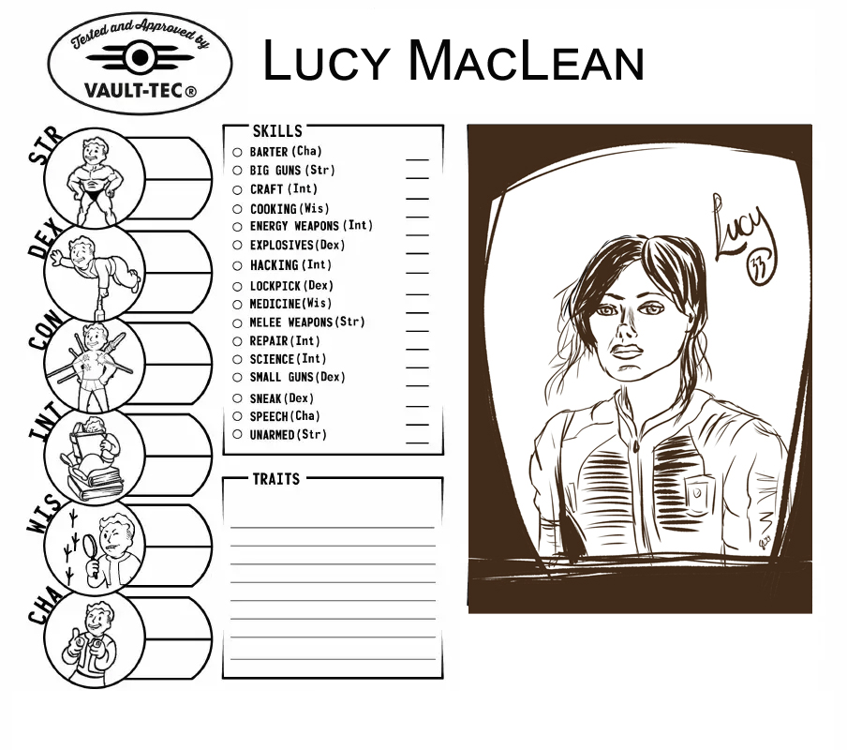

- What score (1-10) would you give yourself for the attributes on the left side? Which three skills would you be best at? Which three would you be worst at?

Part 5a Speaking Prepare and give your own self-introduction using Lucy’s language and organization.
My name is [ name ], and I'm an active contributor to the well-being of my community.
[ an active hobby ].
I enjoy participating in [ more specific ], which keeps me active.
[ skill your family member is good at ].
Obviously, mine are nothing compared to my [ family member's ], but I always relish a challenge.
[ your passion - general ].
My primary passion is [ your passion - more specific ] with a focus on [ even more specific ].
I also participate in [ other interest ], and I dabble in [ not strong skill ], though I'm not very good.
In my personal time, I enjoy [ hobby ] and [ hobby ].
So, it is with sound mind and body that I hereby submit my application to the council to participate in the Triennial Trade with Vault 32.

Part 5b Listening Who do you think gave the best self-introduction in your group? Who do you think would be chosen to participate in the Triennial Trade with Vault 32? Why?

Part 6 Language Review Choose the word or expression from the video that best matches the highlighted expressions.
- My name is Lucy MacLean, and I'm an active contributor to the [ health/happiness] of my community.
- Obviously, mine are nothing compared to my dad's, but I always [ enjoy ] a challenge.
- I [ experiment with ] riflery, though I'm not very good.
- We're still trying to get my brother [ to participate ]. He'll [ join ] when he's ready.
- My reproductive organs are [ undamaged ], my hygiene well-maintained.
- And yet, I have been unable to find a [ appropriate ] marriage partner.
- So, it is with [ healthy ] mind and body that I hereby submit my application to the council to participate in the Triennial Trade with Vault 32.

Script .
My name is Lucy MacLean, and I'm an active contributor to the well-being of my community.
Repair Skills.
I enjoy participating in the Young Pipefitter's Association, which keeps me active.
Science Skills.
Obviously, mine are nothing compared to my dad's, but I always relish a challenge.
Speech Skills.
My primary passion is teaching American history, with a focus on ethics.
I also participate in gymnastics club, Fencing Team C, intermediate Phys. Ed., and I dabble in riflery, though I'm not very good.
In my personal time, I enjoy taking walks and watching movies with my dad, gardening, also with my dad, and participating in my family book club.
We're still trying to get my brother on board. He'll come around when he's ready.
My reproductive organs are intact, my hygiene well-maintained.
And yet, I have been unable to find a suitable marriage partner. At least, one I'm not related to, and we have rules about that for a reason.
So, it is with sound mind and body that I hereby submit my application to the council to participate in the Triennial Trade with Vault 32.

Answers .
Part 2
- Lucy's father is highly skilled in [ science ].
- Lucy [ seems ] to enjoy science.
- Lucy teaches [ history ].
- Lucy [ isn’t ] highly skilled in riflery.
- Lucy likes to watch movies with her [ father ].
- Lucy participates in the family book club with her [ father ].
- Lucy [ is ] able to have children.
- Lucy wants to get married to someone in [ another vault ].
- The vaults do exchanges once [ every three years ].

Part 6
1. My name is Lucy MacLean, and I'm an active contributor to the [ well-being ] of my community.
2. Obviously, mine are nothing compared to my dad's, but I always [ relish ] a challenge.
3. I [ dabble in ] riflery, though I'm not very good.
4. We're still trying to get my brother [ on board ]. He'll [ come around ] when he's ready.
5. My reproductive organs are [ intact ], my hygiene well-maintained.
6. And yet, I have been unable to find a [ suitable ] marriage partner.
7. So, it is with [ sound ] mind and body that I…

